Problem2

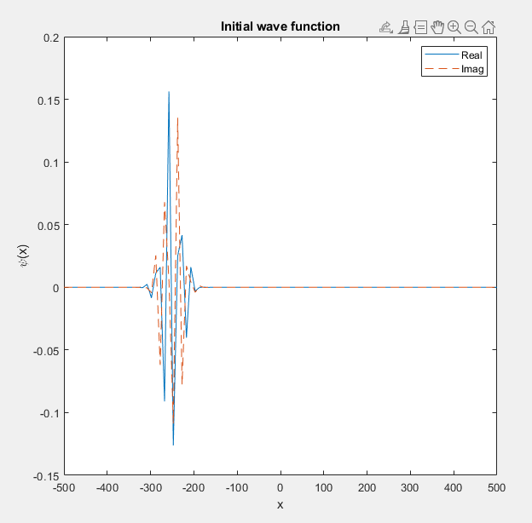

Initial wave for u= 0.5

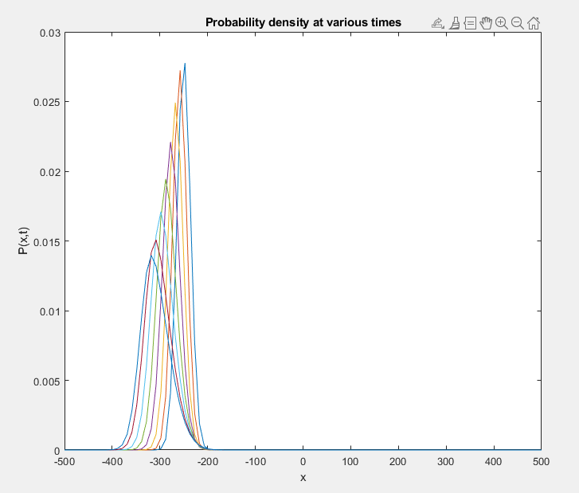

Probability density for u=0.5

Amplitude of the packet is 0.0278 for u=0.5

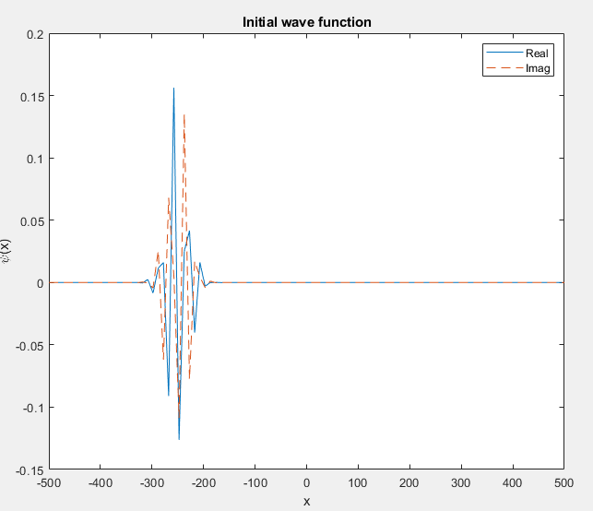

Initial wave for u= 2

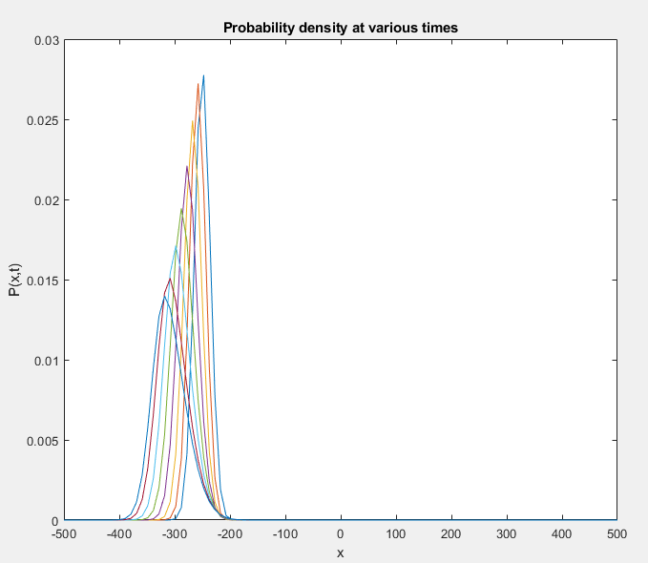

Probability density for u=2

Amplitude of the packet is 0.0277 for u=2

From plot, we can find wavepacket is partially transmitted and partially reflected.